# **Mount Kali Linux**

## ***1. Import Kali Linux OVA file***

- File - Import Appliance

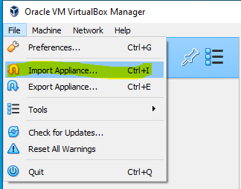

- Select the Kali Linux (Kali-linux-2023.ova)

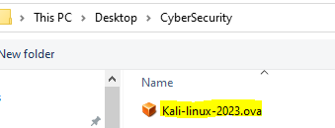

**- Check that RAM size is 2,048MB**

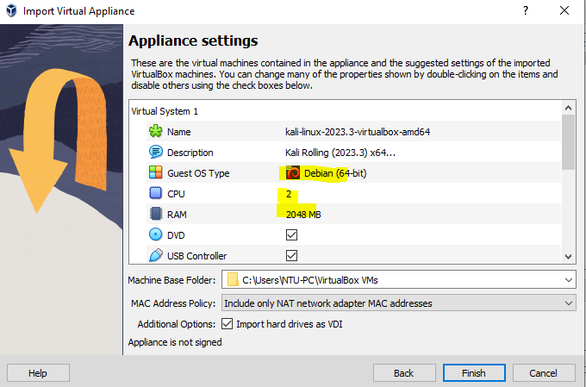

- After import, you can find Kali Linux in the list

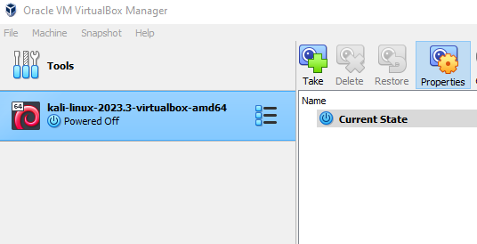

## ***2. Run Kali Linux***

- Click Kali Linux

- login with **root / toor**

- Open console

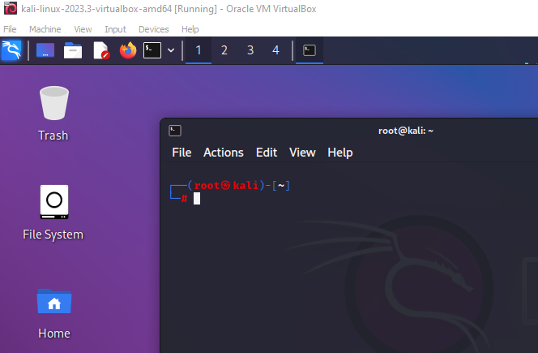

- If the private firewall is on in your PC, DHCP is not working.

So, please check that the firewall is off like this

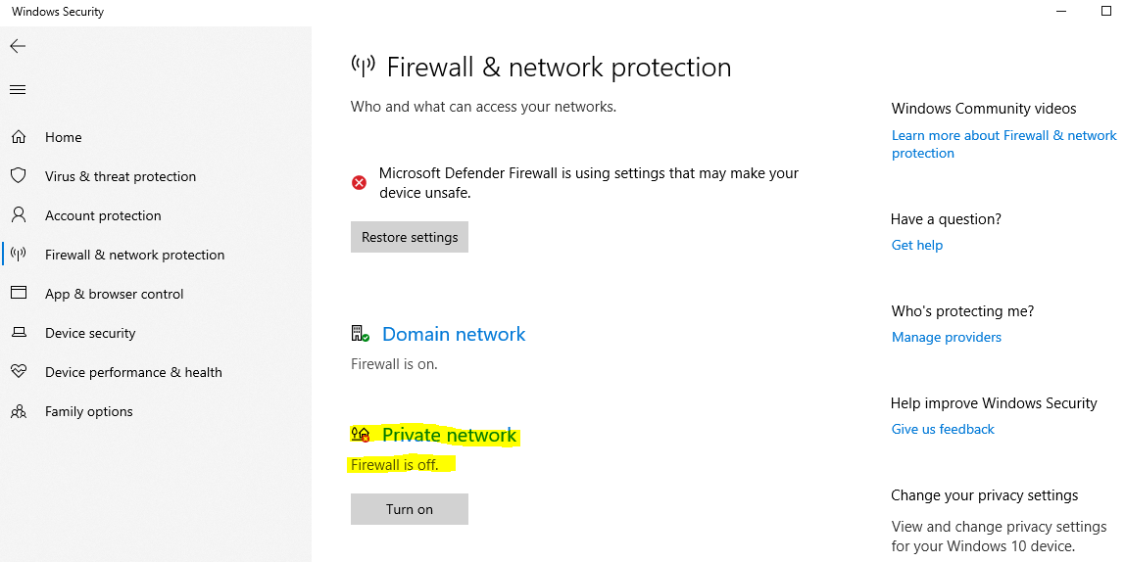

## 

## ***3. Check Network***

- Check IP

Kali> ifconfig

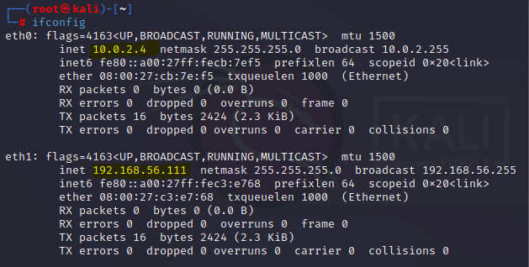

If eth0 is 10.0.2.4 and eth1 is 192.168.1.111, it is Ok.

- Add route

Kali> route add default gw 10.0.2.1

- Check Internet

Kali> ping google.com

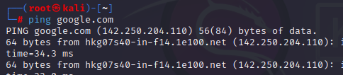

- Check SSH server

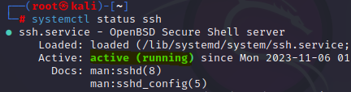

- Back to shell

Ctrl + C

## 

## ***4. Connect Kali from your PC using SSH***

- Generate Key (just one time)

Your PC> ssh-keygen -R 192.168.56.111

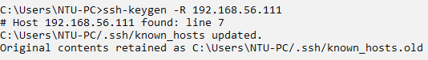

- Connect

Your PC> ssh root@192.168.56.111

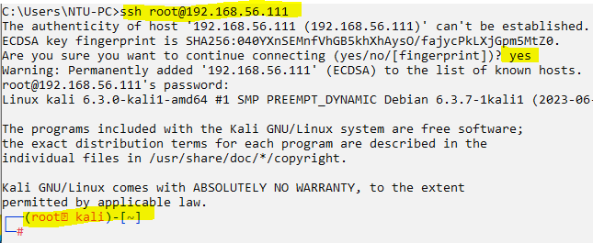

-You can open many terminal to the Kali Linux